Lecture Week- 17
Capital Financing and Allocation

Capital Financing and Allocation

Capital financing and allocation is the process of allocation and distribution of financial resources with a purpose of enhancing long-term financial stability

Another purpose of Capital financing and allocation is value addition from allocation of finances to provide fair returns to providers of capital covering risks

Capital allocation decisions are made at higher level by the management and at country level by the policy makers

Decision of financial investment are considered a strategic or policy decision

Decision to invest must be arrived after considering all relevant aspects like where investment to produce positive yield or better MARR
Capital financing is the process through which a investor uses judgment to determine whether to invest or decline from investment based on the merits and de-merits

What could be the possible risks associated with investment that can be expected at the time of investment. It is necessary that risks may be anticipated and efforts made to address risks prior to investment together with what obstacles can affect cash inflow or cash out flow?

Mode of financing could be investment by investor or with shareholder or borrowing from Bank or any financial institution like lease or credit to pay back with compound interest.

Budget or financial control is also included in Capital Financing and Allocation to ensure financial discipline for a reliable Capital Financing and Allocation.

Capital Financing and Budgeting

Capital Budgeting

Budgeting is one year financial plan to incur expenditure on various items of works or other specified services in accordance with financial rules and financial discipline
Capital Financing and Budgeting

Capital Budgeting and financing is the planning process to determine whether an organization’s long term investments for machinery, material equipment and R&D projects were worth funding through firms resources. It is a process allocating funds for major capital expenditure through funding of financial institutions and shareholders equity holders finances. Many key economic indicators are adopted to examine whether or not Capital Financing and Budgeting was done satisfactory.
For this purpose following economic indicators are considered: B/C ratio, PB Period, PI, NPV and IRR.

Planning Budgeting and Forecasting
Planning provides basis for an organization on how to achieve organizations objectives over one or 2 or 3 or 5 year period through budget allocation according to its corporate development plan
Forecasting takes into consideration the historical data, current status and based on this information makes projections for the future how income can be increased and generated and how expenditure could be controlled for benefit to gain profit

Financial Leverage
Financial leverage is the use of borrowed money (debt) to finance the purchase of assets even money or capital with the expectation that the income or capital gain from the new asset will exceed the cost of borrowing

In most cases, the provider of the debt will put a limit on how much risk it is ready to take and indicate a limit on the extent of the leverage it will allow.

In the case of asset-backed lending, the financial provider uses the assets as collateral or security or guarantee until the borrower repays the loan.

In the case of a cash flow loan, the general credit worthiness of the company is used to back the loan

How Financial Leverage Works

While purchasing assets, three options are available to the company for financing:
use equity, debt, and leases.

Equity Financing
Equity financing refers financing through shareholders. In equity financing shareholders make investment and receive dividend depending upon shareholders share in investment.

Debt Financing
Debt financing depends upon borrowing investment amount from the bank that has to be returned and paid back with interest.

Equivalent Uniform Annual Cost (EUAC) or Annualized Cost 1. EUAC represents average annual cost of project that is value of A.

- EUAC is a method to compare 2 or more projects on the basis of annual cost of Project.
- In case of 02 or more projects the alternative having lowest EUAC is recommended.

- Equation

Functional Equation

To find A given P

Functional Equation = P (A/P, i%, n) – SV (A/F, i%, n) + O&M …………………… (1)

General Equation

EUAC = P [i(1 + i)^{N} / (1 + i)^{N} – 1 ] - SV [ i / (1 + i)^{N} – 1] + O&M……….……. (2)

Problem 2. Determine EUAC of following 2 projects for given values:

Break-up | Project A | Project B | Project C
Initial Cost | $ 15,000 | $ 25,000 | $ 8,000
O & M Cost | $ 1600 | $ 400 | $ 900
Salvage Value (SV) | $ 3,000 | $ 6000 | $ 500
Life year | 7 year | 10 year | 8 year
I | 12% | 12% | 6%

- Calculate EUAC of Project A, Project B and Project C and suggest which project is desirable.

- Draw Cash Flow Diagram of both projects.

Solution

Equation 1 as applicable

EUAC = P [i(1 + i)^{N} / (1 + i)^{N} – 1 ] - SV [ i / (1 + i)^{N} – 1]

Project A

Substituting given values in above equation

EUAC_{A} = 15000 (A/P, 12%, 7) + 1600 – 3000 (A/F, 12% 7)

EUAC_{A} = 15000 0.12 (1 + 0.12)⁷ + 1600 – 3000 _____0.12_____
(1 + 0.12)⁷ – 1 (1 + 0.12)⁷ – 1

= 3,287 +1600 – 297 EUAC_{A} = $ 4,590

Project B
Equation 1 a is applicable
EUAC = P [i(1 + i)^{N} / (1 + i)^{N} – 1 ] - SV [= i / (1 + i)^{N} – 1]

Project B
Substituting given values in above equation

EUAC_{B} = 25000 0.12(1 + 0.12)¹⁰ + 400 – 6000 ____0.12_____
(1 + 0.12)¹⁰ - 1 (1 + 0.12)¹⁰ – 1

EUAC_{B} = 4,425 + 400 – 342
EUAC_{B} = 4,483
EUAC_{A} = $ 4,590
EUAC_{B} = $ 4,654
EUAC_{B} < EUAC_{A}

Equation 1a is applicable
EUAC = P [i(1 + i)^{N} / (1 + i)^{N} – 1 ] - SV [ i / (1 + i)^{N} – 1]

Substituting given values in above equation

Project C
EUAC = 800(A/P, 6%, 8) – 500 (A/F, 6%, 8)

EUAC = 8000 0.06(1 + 0.06)⁸ - 500 ___ 0.06____
- + 0.06)⁸ – 1 (1 + 0.06)⁸ - 1

EUAC = 8000 0.06 (1.06) ⁸ - 500 0.06____ (1.06) ⁸ – 1 (1.06) ⁸ – 1

EUAC = 8000 0.06 (1.59) - 500 0.06___
1.59 – 1 1.59 - 1
EUAC = 8000 0.095 - 500 0.06
0.59 0.59
EUAC = 8000 (0.16) - 500 (0.10)
EUAC = 1280 - 50
EUAC = $ 1230
Add O&M or AOC
EUAC = $ 1230 + $900
EUAC = $ 2130
Therefore Project B is recommended.

Problem 3
Two routes are under consideration for a new interstate highway. The north route N would be located about 5 miles from the central business district and would require longer travel distances by local commuter traffic. The south route S would pass through the downtown area and although its construction cost would be higher it would reduce the travel time and distance for local commuters. Assume the costs for the two routes are as follows:

Category | Route N | Route S
Initial Cost | $10,000,000 | $15,000,000
Maintenance Cost / Year | $ 35,000 | $ 55,000
Road user cost / Year (Toll Tax) | $ 450,000 | $ 200,000

The roads are assumed to last 30 years with no SV.

Calculate:
EUAC of Route N and Route S
Do you recommend Route N or Route S

Solution

EUAC_{P} = P i (1 + i)^{n}_ - SV ___i_____ + O&M ……………………………… (1)
(1 + i)^{n} - 1 (1 + i)^{n} – 1
Route N
Substitute values in Equation (1)

EUAC_{N} = $10,000,000 5% (1 + 5%)³⁰ + 35,000
(1 + 5%)³⁰ - 1
EUAC_{N} = $ 685, 500

Route S
Substitute Values in Equation (1)

EUAC_{S} = $15,000,000 5% (1 + 5%)³⁰ + 55,000
(1 + 5%)³⁰ - 1

EUAC_{S} = $ 1,030,750

Annual Cost Difference between Route S & Route N

= EUAC_{N} - EUAC_{S}

= 1,030,750 – 685,500

= $ 345,250

Annual Cost of Construction & Maintenance of Route N is more economical by $ 345,250.

Now
Cost to users for using Route N/year = $ 450,000
Cost to users for using Route N/year = $ 200,000

Route S is more economical for users by $ 250,000 / year
Thus
- EUAC of Route N and EUAC of Route S
- Route is more economical from user’s point of view.

Problem 4.
Alternative routes are being considered by the State Highway Department for location of new highway. Route A costing $ 4,000,000 to build will provide annual benefits of $ 125,000 to local business. Route B would cost $ 6,000,000 will provide $ 100,000 in benefits. The annual cost of maintenance is $ 200,000 for A and $ 120,000 for B, respectively. If the life of each road is 20 years and interest rate of 8% is used.

Calculate:
EUAC of Route A and EUAC of Route B
Which Route you Recommend

Solution

EUAC of Route A and EUAC of Route B:
Equation

EUAC_{P} = P i (1 + i)^{n}_ - SV ___i_____ + O&M
(1 + i)^{n} - 1 (1 + i)^{n} – 1
Substitute values in Equation No.1
Route A

EUAC_{A} = $ 4,000,000 __8% (1 + 8%)²⁰ + 200,000
(1 + 8%)²⁰ – 1
EUAC_{A} = $ 607,400

Route B

EUAC_{A} = $ 6,000,000 _8% (1 + 8%)²⁰ + 120,000
(1 + 8%)²⁰ – 1
EUAC_{B} = $ 731,000

Annual Cost difference between Route A & Route B
= EUAC_{B} – EUAC_{A}
= $ 731,000 - $ 607,400
= $ 123,000

Annual Cost of Construction & Maintenance of Route A is less and more economical by $ 123,000

Now

Benefit of Route A = $ 125,000
Benefit of Route B = $ 100,000

EUAC of Route A is more economical Benefit of Route A are higher Route A is recommended.
Goods Market and Money Market Economy

Goods Market
By Goods Market we mean all the buying and selling of goods and services.

Goods markets are markets in which companies and households interact to buy and sell the output of goods and services.

In this market households act as buyers, while companies act as sellers.

This role in Goods Market changes in money market where production and transaction takes place.

The equilibrium level of output is determined in the goods market.

Money Market
By Money Market we mean the interaction between demand for money and the supply of money (the size of the money stock) is set by the State Bank working through the banking system

The equilibrium interest rate is determined in the money market.

The money market contributes to the economic stability and development of a country by providing short-term liquidity to governments, commercial banks, and other large organizations.

Investors with excess money that they do not need can invest it in the money market and earn interest.

One of the main differences between the money market and the stock market is that most money market securities trade in very high denominations.

Furthermore, the money market is a trader market, which means that firms buy and sell securities in their own accounts, at their own risk.

Goods Market and Money Market Economy

The number of suppliers in a market defines the market structure.

Economists identify four types of market structures:
- Perfect Competition,
- Pure Monopoly,
- Monopolistic Competition
- Oligopoly - less number of firms dominate market

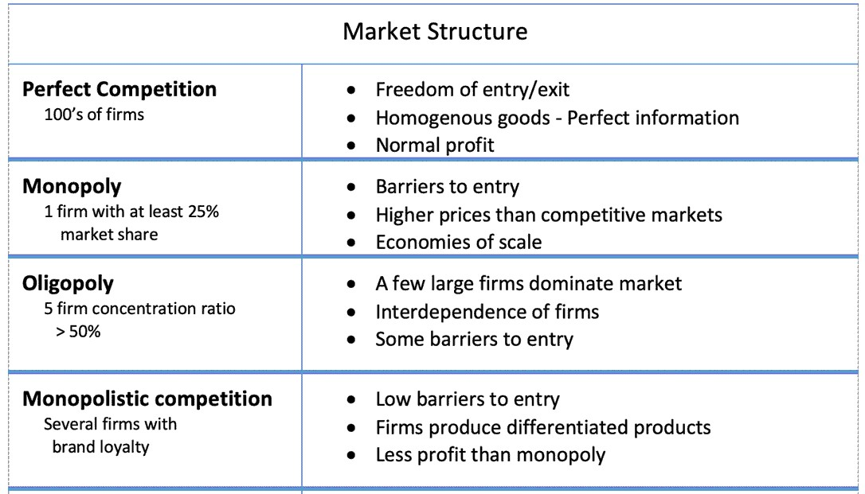

Cartel

